

## Walchand College of Engineering, Sangli

#### (An Autonomous Institute)

**Department of Computer Science and Engineering**

TY CSE Mini Project 1

Report on

**Used-Car Price Predictor**

Submitted by

|  |  |
| --- | --- |
| **Aniket Rahul Khare** | **21510047** |
| **Prathamesh Sidram Basapure** | **21510044** |
| **Aditya Pralhad Kumbhar** | **21510052** |

Under the guidance of

**N.L.Mudegol**

Department of Computer Science and Engineering,

Walchand College of Engineering, Sangli

**2023 - 2024**



**Walchand College of Engineering, Sangli**

(An Autonomous Institute)

**Department of Computer Science and Engineering**

### CERTIFICATE

This is to certify that the Project Report entitled, **“USED CAR PRICE PREDICTOR”** submitted by Mr. Aniket Khare, Mr.Prathamesh Basapure, Mr.Aditya Kumbhar, to Walchand College of Engineering Sangli, India, is a record of bonafide project work of course **Mini Project-1** **6CS341**carried out by him/her under my/our supervision and guidance and is worthy of consideration for the award of the degree of Bachelor of Technology in Computer Science & Engineering of the Institute.

|  |  |  |
| --- | --- | --- |
| **N.L.Mudegol** |  | **Dr. M. A. Shah** |
| **Guide** | **External examiner** | **Head Of Department** |
| Department of Computer Science and Engineering, |  | Department of Computer Science and Engineering, |
| Walchand College of Engineering, Sangli |  | Walchand College of Engineering, Sangli |

# Acknowledgement

The acknowledgement page depicts the gratitude, respect and thankfulness of the student towards the people who helped him in pursuing the project successfully and ensured successful completion and implementation of the project. In this page, the author expresses his gratitude and concern by using praising and thanks giving words.

(Acknowledgement to Director, HOD, Project Coordinator, Guide: Institute as well as Industry n others)

# Declaration

I hereby declare that work presented in this project report titled **“USED CAR PRICE PREDICTOR”** submitted by me in the partial fulfillment of the requirement of the award of the degree of **Bachelor of Technology (B. Tech)** in the **Department of Computer Science & Engineering, Walchand College of Engineering, Sangli** is an authentic record of my project work carried out under the guidance of N.L.Mudegol

Date:

Place: Sangli

**Aniket Khare**

**Prathamesh Basapure**

**Aditya Kumbhar**

## Table of Contents

Abstract 7

1. Introduction and Related work 8
2. Problem statement 8
3. Objectives 9
4. Methodology 10
5. Project Diagrams (UML diagrams, Flow chart etc.) 11
6. Testing (Unit, System, Integration etc.) 13
7. Results and Conclusion 15
8. References 16

###### List Of Figures

* + figure 1 example
  + figure 1 example

###### Acronyms

* + AN Acronym name example
  + AN1 Another name

#### Abstract

**Predicting Second-Hand Car Prices with Machine Learning**

The second-hand car market is a substantial and complex industry, with various factors influencing the prices of used cars. Accurately estimating the resale value of a car can be challenging due to the interplay of multiple parameters such as the car's make, model, year of manufacture, mileage, fuel type, and various other features. This project aims to leverage machine learning and data science techniques to develop a regression model capable of predicting the second-hand price of cars based on historical data.

This project focuses on developing a machine learning-based regression model to predict second-hand car prices. By analyzing a dataset containing key parameters such as car details, location, year, mileage, and more, we aim to provide accurate estimates of resale values. This model has the potential to enhance decision-making for buyers and sellers in the second-hand car market, streamlining pricing decisions and promoting transparency.

#### Introduction and Related work

The automotive industry has witnessed a significant surge in the sale and purchase of used cars, driven by factors such as economic considerations, increased awareness of environmental sustainability, and a growing demand for affordable transportation solutions. One crucial aspect of the used car market is determining the fair and accurate pricing of pre-owned vehicles. Predicting the price of a used car is a complex task influenced by various factors, including the make and model of the vehicle, its age, mileage, condition, and market trends.

Studies and projects have delved into the realm of predicting used car prices using various machine learning techniques. Previous research in this domain has focused on feature engineering, dataset preparation, and model fine-tuning to enhance the predictive accuracy of linear regression models. Some studies have incorporated additional machine learning techniques, such as feature scaling, regularization, and ensemble methods, to improve the overall performance of used car price prediction models.

Moreover, researchers have investigated the impact of different features on the accuracy of linear regression models. Common features include mileage, vehicle age, brand reputation, fuel efficiency, and geographic location. Understanding the significance of these features is crucial for refining the model and ensuring its applicability across diverse markets.

#### Problem statement

To create a robust regression model using machine learning techniques to predict the second-hand price of cars. Given a dataset containing various parameters related to cars, such as the car's name, location, year of manufacture, kilometers driven, fuel type, transmission, owner type, mileage, engine capacity, power, seats, and the second-hand price, the goal is to build a predictive model that can accurately estimate the resale value of a car based on these parameters.

#### Objectives

#### 

1.To create an efficient and effective model that estimates the price of a used car based on the inputs of the user.

2. To obtain high precision.

3. To create a user-friendly User Interface (UI) that receives input from the user and forecasts the pricing

#### Methodology

The project utilizes a combination of tools, frameworks, and algorithms to achieve its goals.

**Frontend Framework:**

We will use HTML,CSS, javascript framework for frontend implementation.

**Backend Framework:**

We will use FLASK (python) framework for backend implementation.

**Development Environment:**

The code implementation will take place within a Jupyter Notebook environment.

**Programming Language:**

Python , javascript.

**Algorithms and Techniques:**

**Linear Regression**: A baseline linear regression model is implemented to establish a benchmark for comparison.

**Decision Trees and Random Forest:** Decision tree-based algorithms are used to capture non-linear relationships among various parameters. The Random Forest algorithm is employed for ensemble learning and improved prediction performance.

#### Project diagrams

1. **Functional Block Diagram :**

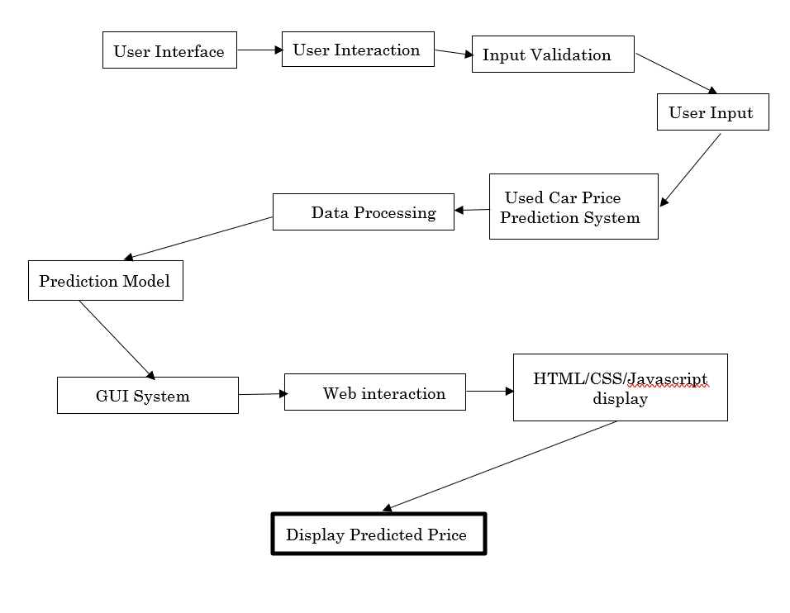

**2.Class Diagram:-**

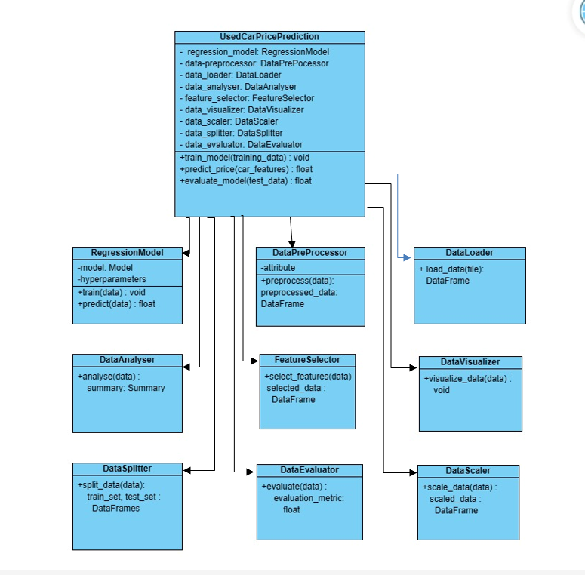

#### Unit Testing:

#### Verified that pickling and unpickling the model using pickle does not result in data loss or corruption.

#### Tested the log transform function for feature normalization to ensure it accurately scales input features.

#### Confirmed the inverse transform function accurately recovers original feature values after log transformation.

#### Integration Testing:

#### Tested the integration of the pickled model within the system, ensuring seamless loading and utilization.

#### Validated the consistent application of log transform across various stages of data processing.

#### Ensure that inverse transform is appropriately applied to obtain interpretable predictions for users.

#### System Testing:

#### Conducted end-to-end testing to confirm the correct utilization of the pickled model in the prediction pipeline.

#### Evaluate system behavior with varying log-transformed input features, ensuring stability and accuracy.

#### Verify that the inverse transform effectively converts predicted log-scaled prices back to the original scale for user presentation.

#### Results and Conclusion

#### 

The used car price predictor simplifies transactions, promotes fair pricing, and aids decision-making for buyers and sellers. Its user-friendly approach and real-time insights contribute to a smoother and more transparent experience in the dynamic used car market as well it makes use of Machine Learning and Data Science algos to study the market trends and correctly predict the price of the used car.

#### References

[1] Data Set

<https://www.kaggle.com/datasets/avikasliwal/used-cars-price-prediction?select=train-data.csv>

[2] Boston housing price prediction case study in python

<https://thinkingneuron.com/python-case-studies/>